Read and edit this in Microsoft Word
with "show hidden text= on"
(that setting is usually in "tools/options/view")

*STATA_APST470

Section #1. Get Stata running on UNR Citrix

1. Log on to UNR DataWorks Citrix server from your browser. Start byGoolgling "unr dataworks" and choosing "DataWorks Lab":
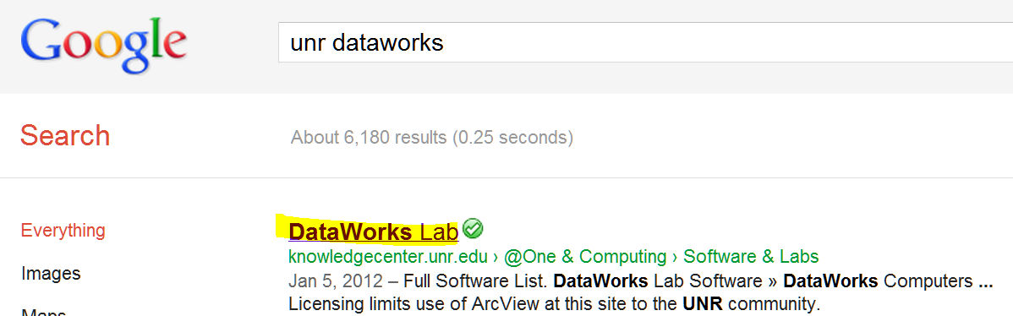

2. Then click through to Citrix and log yourself in with your UNR ID:
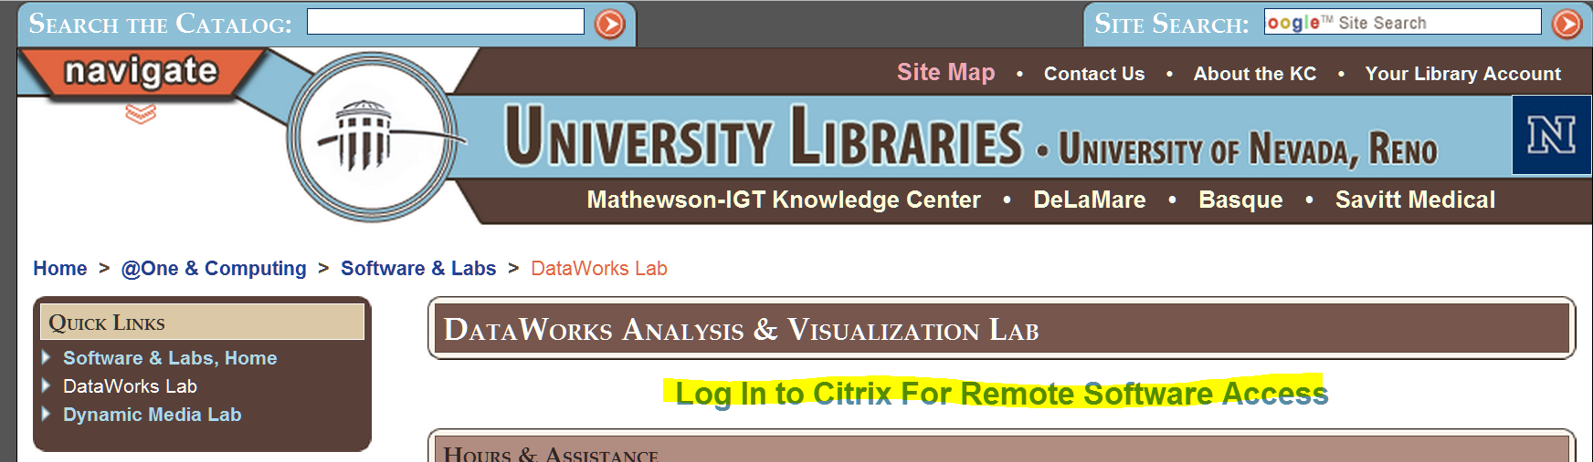

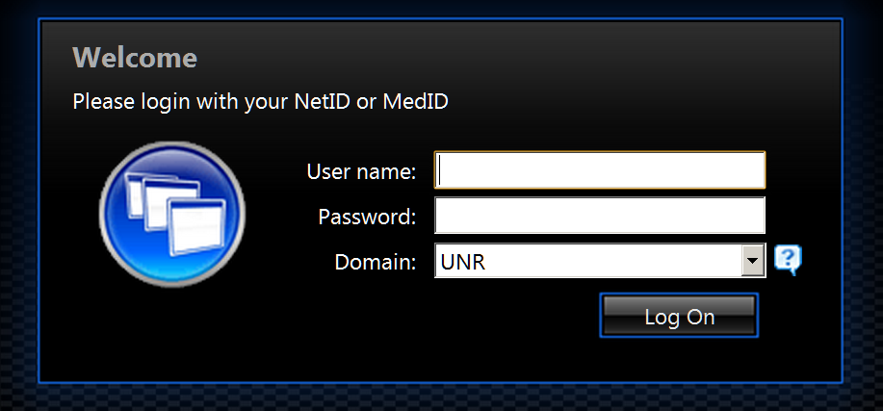

3. Find Stata and double click on it:
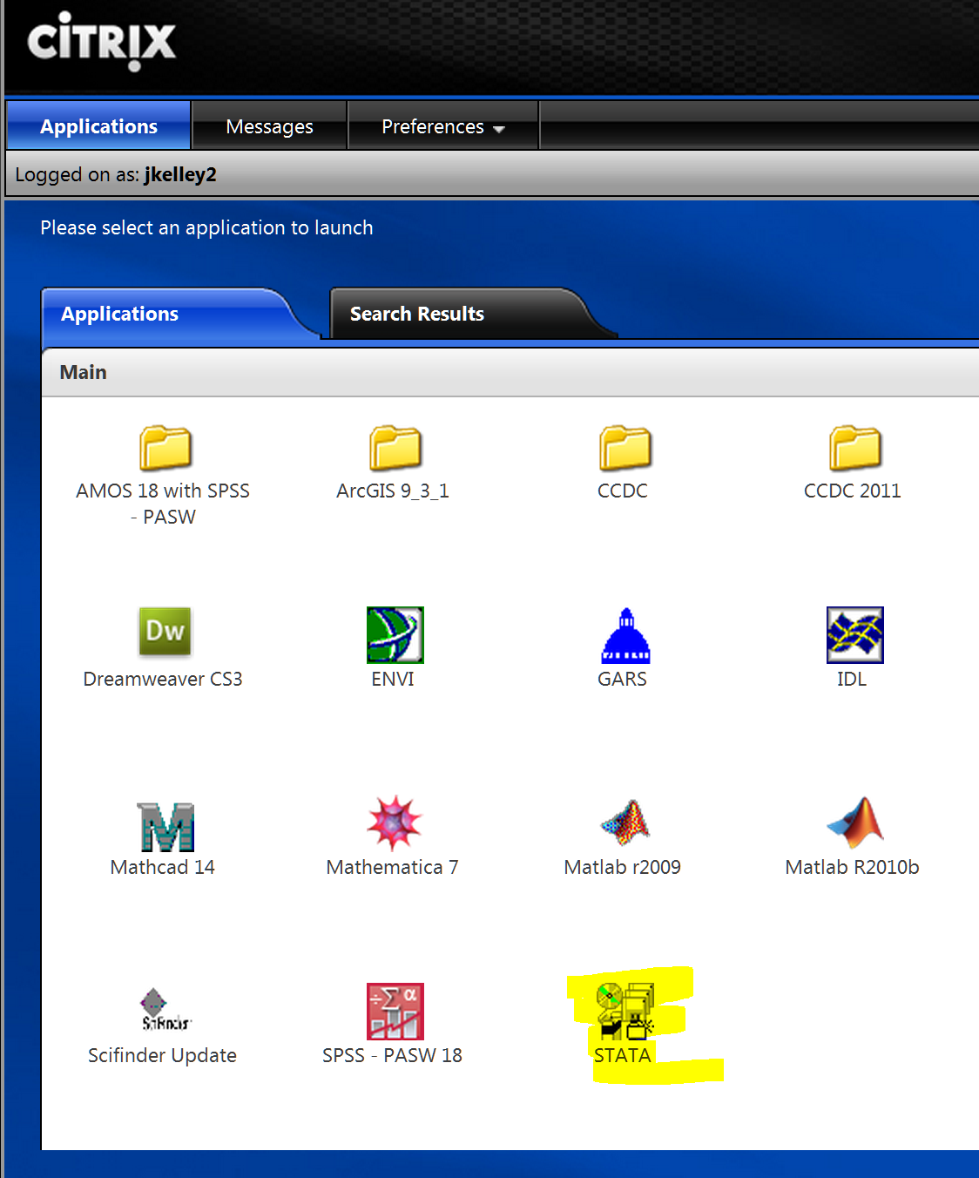

Sometimes Citrix will launch Stata immediately. Other times it wants you to save a small shortcut file -- if so, double click on it to get Stata. (In my browser, Google Chrome, after you save, it appears in the lower left hand corner and you double click it directly from there.)
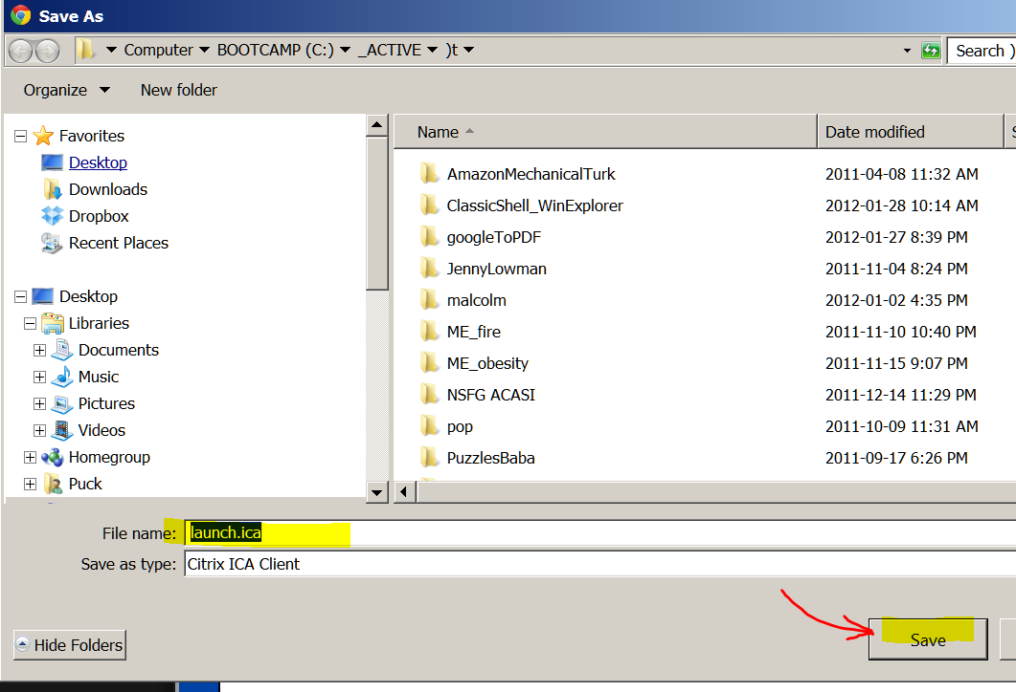

4. Stata then opens. Expand the "Results window" so you can see everything conveniently. Now you are ready to run Stata.

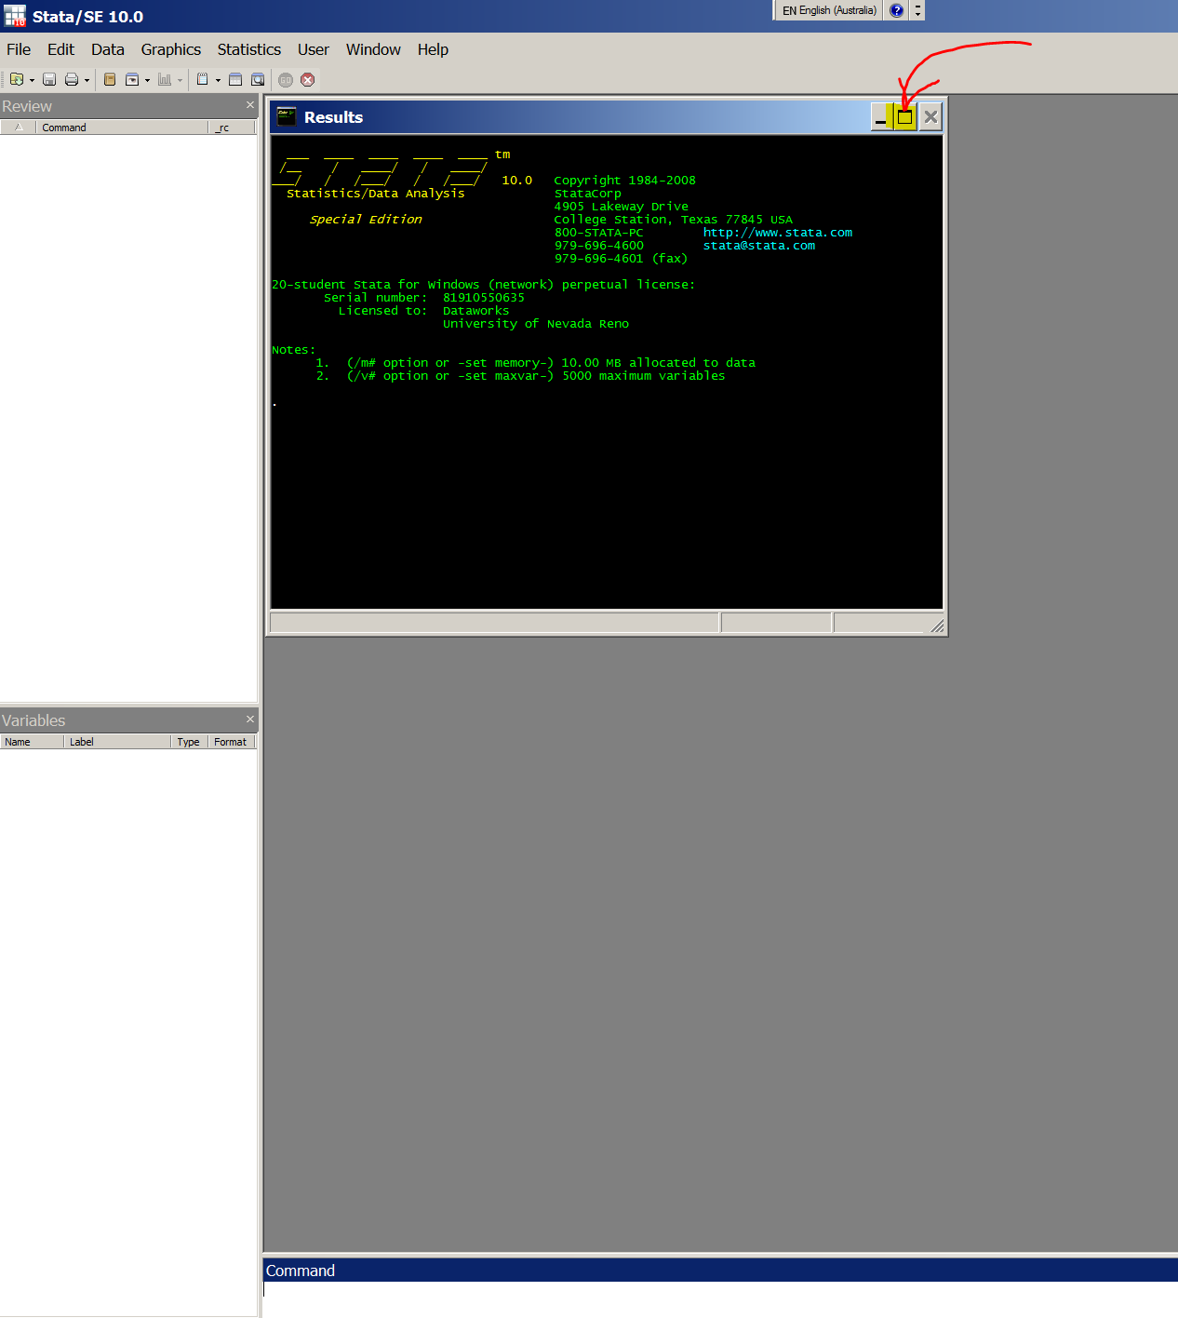

5. In Stata choose:
WINDOW/ DO FILE EDITOR / NEW DO-FILE

to open a "do file" window (so you can paste a whole batch of things in it to run at one go):

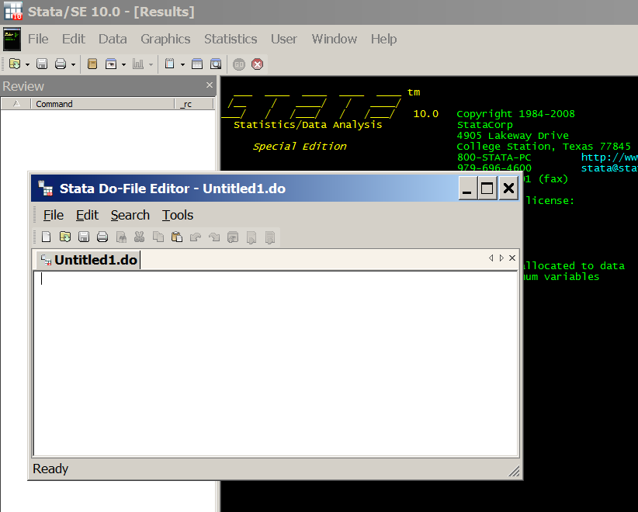

A. For the first time you run things on Citrix you have to do things this way, afterwards another way.

6. Copy-and-paste into the Stata "do file" the following (just to set up Stata conveniently):
clear
set memory 400m
set more off, permanently
set varlabelpos 12
set varabbrev off
set scrollbufsize 250000

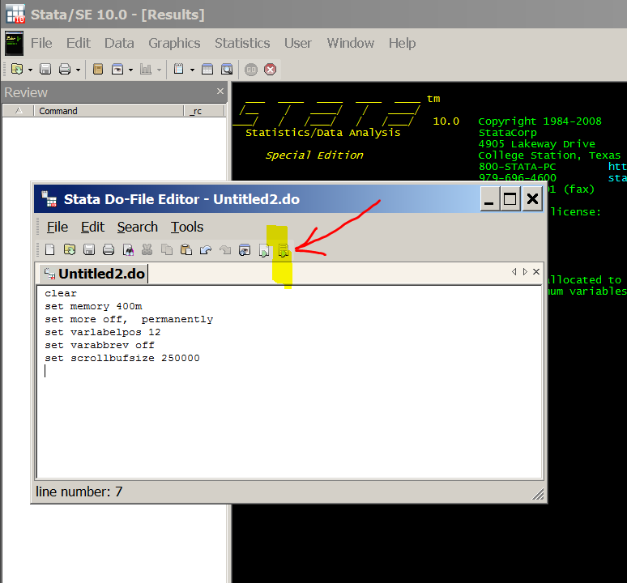

7. run (use the icon to the far right in the do file)

8. Now comes the hard part (but you will only have to do it the first time you run things on Citrix). You need to find the data. In Stata choose:
FILE/ OPEN
and navigate to YOUR computer (or data stick or wherever you have the data file). It is probably drive "V" and you may have to click on three things in a row to get there (and perhaps expand the window to get enough room to see things):
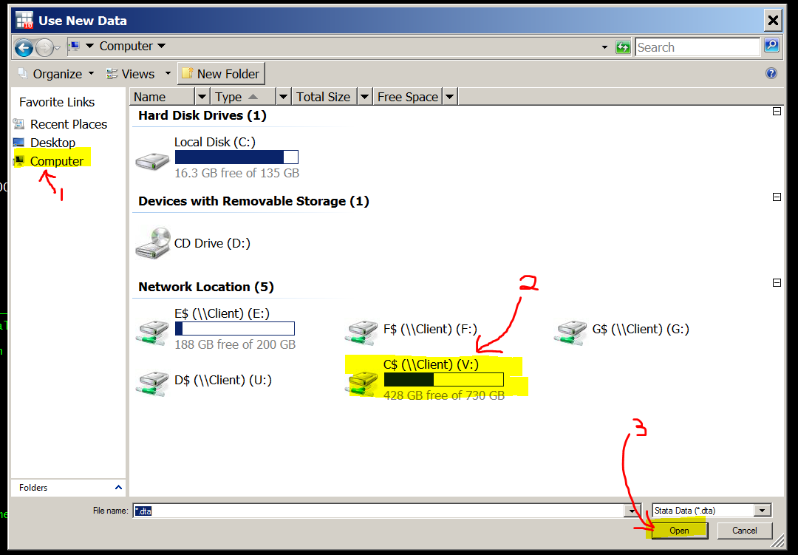

Then navigate to the data file -- it will be where you saved it on your computer. This is where it is on my machine, yours will be different. The file we are after is IsssUSA_AnalysisVars_1.dta . The ".dta" extension will probably not show up (it is there but the Citrix default is not to show it). Open the file:
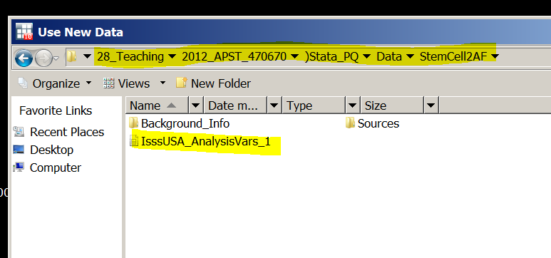

Stata will then get the data and (conveniently) show the command it used in the "Results" window:

9. Copy that line (sweeping it followed by Control-C will get it):
use "V:\_ACTIVE\28_Teaching\2012_APST_470670\)Stata_PQ\Data\StemCell2AF\IsssUSA_AnalysisVars_1.dta", clear

It may look a bit funny on the screen if there are more than 80 characters, as in my example just above. But that does not bother Stata.

Then paste it into the text just below (in Section #2 of THIS document) for future use. Do it where it says:
*Change the bit in red to reflect your file location.

B. AFTER the first time you run things on Citrix, it is much easier. Do it this way:

You will have pasted the file location on your computer into the text in Section #2 below in this file. Copy and past all of Section #2 (in the grey box) into the Stata do file and run it:

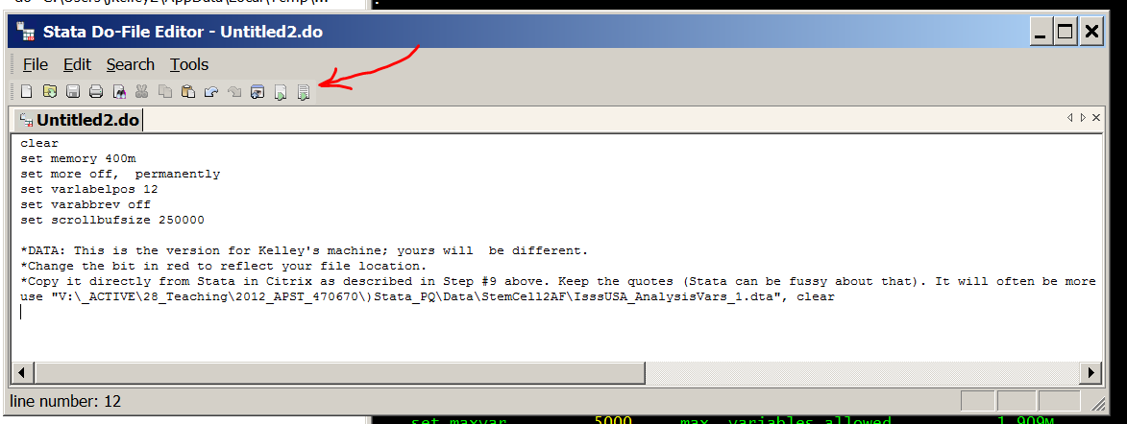

This is what the Stata "Results" screen will look like.
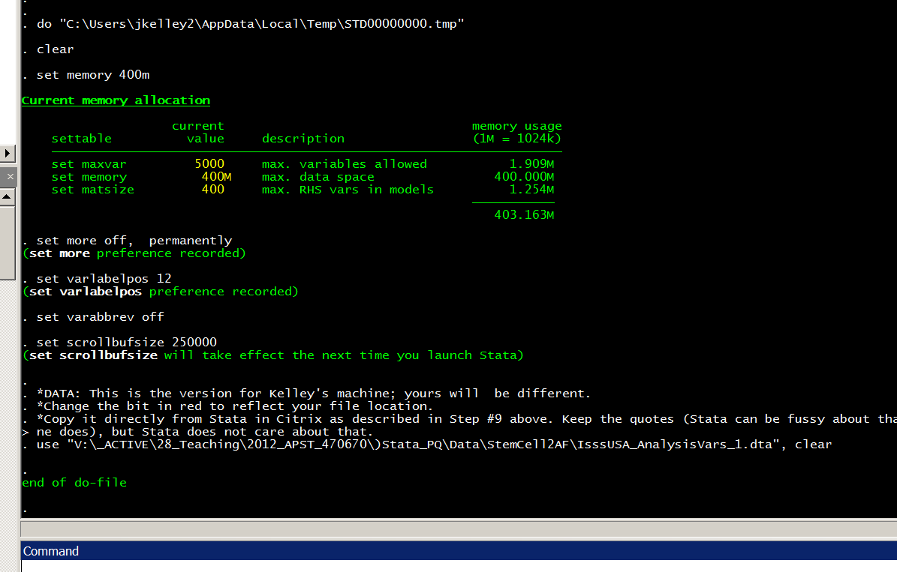

All is well; you are up and running.

*Section #2: Standard Stata set up to read the data
NORMAL PROCEDURE
(1) Start Stata (see the notes above in Section #1)

(2) Copy and paste all of this (Section #2 in the grey box below) in a Stata do-file. Run it. (See Section #1 above, Part B, for notes on how to do that.)

(3) Then run everything in Section #3 (there won't be anything there for the first week or two, but afterwards there will be).
- Open a do-file
- Erase anything that is in it already
- Paste all of Section #3 in the do-file.
- Run it.
That gets Stata up and running, with all the basic variables defined & ready to go. You must do this once at the beginning of your session -- you can not pick and choose, but need to run everything in Sections #2 and #3.

(4) Afterwards, run anything you want from Section #4, which has the week-by-week stuff. You can pick and choose here, running only the bits you want and ignoring the rest.

Do not worry about material in hidden text (usually in a blue box like this one) as it will not be copied.

clear
set memory 400m
set more off, permanently
set varlabelpos 12
set varabbrev off
set scrollbufsize 250000

*DATA: This is the version for our home machine; yours will be different.
*Change the bit in red to reflect your file location.
*Copy it directly from Stata in Citrix as described in Step #9 above. Keep the quotes (Stata can be fussy about that). It will often be more than 80 characters and look funny on the screen (as mine does), but Stata does not care about that.
use "V:\_ACTIVE\28_Teaching\2012_APST_470670\)Stata_PQ\Data\StemCell2AF\IsssUSA_AnalysisVars_1.dta", clear

*Section #3: variable definitions & other preliminaries

As yet, there is nothing in this section.

*Section #4: Analysis (week-by-week material)

*Week 2 material

*Regression with a single dichotomous variable
tab1 maleQ cIPS9
-> tabulation of maleQ

RECODE of |
Sex | Freq. Percent Cum.
------------+-----------------------------------
0 | 1,100 51.21 51.21
1 | 1,048 48.79 100.00
------------+-----------------------------------
Total | 2,148 100.00

-> tabulation of cIPS9

cIPS9 | Freq. Percent Cum.
------------+-----------------------------------
0 | 147 6.59 6.59
8.333333 | 7 0.31 6.90
16.66667 | 12 0.54 7.44
25 | 79 3.54 10.98
33.33333 | 50 2.24 13.22
41.66667 | 67 3.00 16.22
50 | 378 16.94 33.15
58.33333 | 135 6.05 39.20
62.5 | 1 0.04 39.25
66.66666 | 215 9.63 48.88
75 | 376 16.85 65.73
83.33334 | 148 6.63 72.36
87.5 | 2 0.09 72.45
91.66666 | 155 6.94 79.39
100 | 460 20.61 100.00
------------+-----------------------------------
Total | 2,232 100.00

table maleQ , c( m cIPS9 freq)
------------------------------------
RECODE of |
Sex | mean(cIPS9) Freq.
----------+-------------------------
0 | 65.01744 1,100
1 | 69.38077 1,048
------------------------------------
disp 69.38 - 65.017
4.363

regress cIPS9 maleQ
Source | SS df MS Number of obs = 2146
-------------+------------------------------ F( 1, 2144) = 13.57
Model | 10208.2396 1 10208.2396 Prob > F = 0.0002
Residual | 1612475.28 2144 752.08735 R-squared = 0.0063
-------------+------------------------------ Adj R-squared = 0.0058
Total | 1622683.52 2145 756.495813 Root MSE = 27.424

------------------------------------------------------------------------------
cIPS9 | Coef. Std. Err. t P>|t| [95% Conf. Interval]
-------------+----------------------------------------------------------------
maleQ | 4.36333 1.184341 3.68 0.000 2.040753 6.685908
_cons | 65.01744 .8272472 78.59 0.000 63.39515 66.63973
------------------------------------------------------------------------------

ttest cIPS9, by(maleQ)
Two-sample t test with equal variances
------------------------------------------------------------------------------
Group | Obs Mean Std. Err. Std. Dev. [95% Conf. Interval]
---------+--------------------------------------------------------------------
0 | 1099 65.01744 .8484643 28.12758 63.35265 66.68223
1 | 1047 69.38077 .8241062 26.66592 67.76368 70.99786
---------+--------------------------------------------------------------------
combined | 2146 67.14624 .5937292 27.50447 65.9819 68.31059
---------+--------------------------------------------------------------------
diff | -4.36333 1.184341 -6.685908 -2.040753
------------------------------------------------------------------------------
diff = mean(0) - mean(1) t = -3.6842
Ho: diff = 0 degrees of freedom = 2144

Ha: diff < 0 Ha: diff != 0 Ha: diff > 0
Pr(T < t) = 0.0001 Pr(|T| > |t|) = 0.0002 Pr(T > t) = 0.9999

*Regression with a single continuous variable

table edNowQ, c(m cIPS9 freq)
------------------------------------
RECODE of |
EdNow | mean(cIPS9) Freq.
----------+-------------------------
10 | 57.93651 42
11 | 74.46236 31
12 | 63.03612 444
13 | 65.65501 729
14 | 68.50394 255
16.5 | 70.70428 453
18 | 73.44377 166
22 | 69.04762 35
------------------------------------

regress cIPS9 edNowQ
Source | SS df MS Number of obs = 2152
-------------+------------------------------ F( 1, 2150) = 24.61
Model | 18409.8391 1 18409.8391 Prob > F = 0.0000
Residual | 1608302.83 2150 748.047829 R-squared = 0.0113
-------------+------------------------------ Adj R-squared = 0.0109
Total | 1626712.67 2151 756.258797 Root MSE = 27.35

------------------------------------------------------------------------------
cIPS9 | Coef. Std. Err. t P>|t| [95% Conf. Interval]
-------------+----------------------------------------------------------------
edNowQ | 1.284678 .2589609 4.96 0.000 .7768386 1.792518
_cons | 49.04121 3.696598 13.27 0.000 41.79192 56.29049
------------------------------------------------------------------------------

*Week 3 material

